W368R-How to manage the router remotely?
Product line: Wireless Question category: Function configarations

Q：Why do we need to configure the Remote Management?
A：Sometimes, if we need to manage router remotely in the office, you can achieve the function by the Remote WEB Management settings.

The topology is as below:

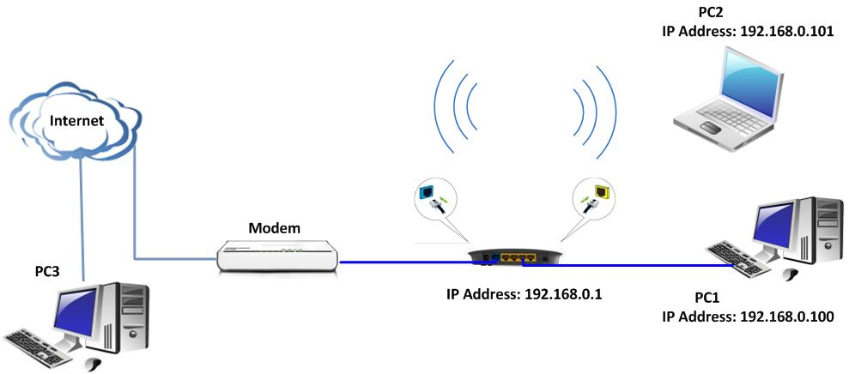

The steps are followings:
1. Login the management page of the router.
2. Click Security settings→Remote Web Management on the top menu of the home page.

For example, if you want to manage the router remotely by the device with IP Address110.110.110.110, you can configure the router as below.
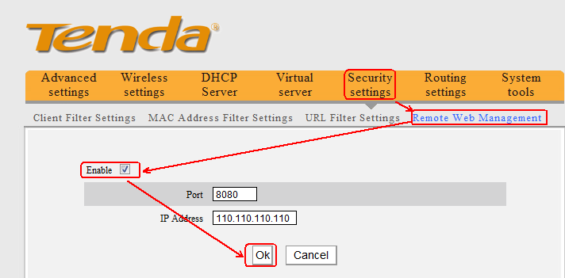

After the settings, the computer with the IP address 110.110.110.110 can manage the router remotely.
Just type the http://the router’s WAN IP Address: 8080 in the address bar and you can login to the management page of the router and it remotely.

Note:
1. Type a specific Public IP address for the Remote Web Management IP Address means that you can only connect to this device remotely from a computer which is using this specific IP address.
2. We suggest you to change the default login Username and Password if you enabled the Remote Management feature, especially you typed 0.0.0.0 as the Remote Web Management IP address.

